3D PYTHGORAS AND TRIGONOMETRY
Pearson Edexcel - Monday 12 November 2018 - Paper 3 (Calculator) Foundation Tier

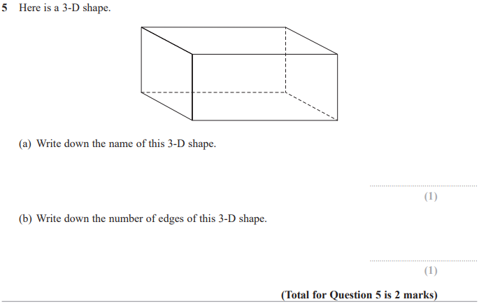

Pearson Edexcel – Specimen 2 - Paper 1 (Non-Calculator) Foundation Tier

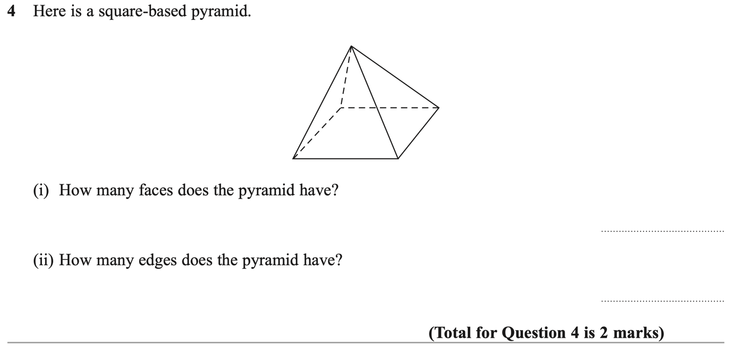
Pearson Edexcel – Specimen 1 - Paper 3 (Calculator) Foundation Tier

